Atmospheric Circulation

As noted earlier, the atmosphere is in constant motion. Certain factors combine to set the atmosphere in motion, but a major factor is the uneven heating of the Earth’s surface. This heating upsets the equilibrium of the atmosphere, creating changes in air movement and atmospheric pressure. The movement of air around the surface of the Earth is called atmospheric circulation.

Heating of the Earth’s surface is accomplished by several processes, but in the simple convection-only model used for this discussion, the Earth is warmed by energy radiating from the sun. The process causes a circular motion that results when warm air rises and is replaced by cooler air.

Warm air rises because heat causes air molecules to spread apart. As the air expands, it becomes less dense and lighter than the surrounding air. As air cools, the molecules pack together more closely, becoming denser and heavier than warm air. As a result, cool, heavy air tends to sink and replace warmer, rising air.

Because the Earth has a curved surface that rotates on a tilted axis while orbiting the sun, the equatorial regions of the Earth receive a greater amount of heat from the sun than the polar regions. The amount of sun that heats the Earth depends on the time of year and the latitude of the specific region. All of these factors affect the length of time and the angle at which sunlight strikes the surface.

Solar heating causes higher temperatures in equatorial areas which causes the air to be less dense and rise. As the warm air flows toward the poles, it cools, becoming denser, and sinks back toward the surface. [Figure 11-3]

Atmospheric Pressure

The unequal heating of the Earth’s surface not only modifies air density and creates circulation patterns; it also causes changes in air pressure or the force exerted by the weight of air molecules. Although air molecules are invisible, they still have weight and take up space.

Imagine a sealed column of air that has a footprint of one square inch and is 350 miles high. It would take 14.7 pounds of effort to lift that column. This represents the air’s weight; if the column is shortened, the pressure exerted at the bottom (and its weight) would be less.

The weight of the shortened column of air at 18,000 feet is approximately 7.4 pounds; almost 50 percent that at sea level. For instance, if a bathroom scale (calibrated for sea level) were raised to 18,000 feet, the column of air weighing 14.7 pounds at sea level would be 18,000 feet shorter, and would weigh approximately 7.3 pounds (50 percent) less than at sea level. [Figure 11-4]

The actual pressure at a given place and time differs with altitude, temperature, and density of the air. These conditions also affect aircraft performance, especially with regard to takeoff, rate of climb, and landings.

Coriolis Force

In general atmospheric circulation theory, areas of low pressure exist over the equatorial regions and areas of high pressure exist over the polar regions due to a difference in temperature. The resulting low pressure allows the high-pressure air at the poles to flow along the planet’s surface toward the equator. While this pattern of air circulation is correct in theory, the circulation of air is modified by several forces, the most important of which is the rotation of the Earth.

The force created by the rotation of the Earth is known as the Coriolis force. This force is not perceptible to humans as they walk around because humans move slowly and travel relatively short distances compared to the size and rotation rate of the Earth. However, the Coriolis force significantly affects bodies that move over great distances, such as an air mass or body of water.

The Coriolis force deflects air to the right in the Northern Hemisphere, causing it to follow a curved path instead of a straight line. The amount of deflection differs depending on the latitude. It is greatest at the poles, and diminishes to zero at the equator. The magnitude of Coriolis force also differs with the speed of the moving body—the greater the speed, the greater the deviation. In the Northern Hemisphere, the rotation of the Earth deflects moving air to the right and changes the general circulation pattern of the air.

The speed of the Earth’s rotation causes the general flow to break up into three distinct cells in each hemisphere. [Figure 11-5] In the Northern Hemisphere, the warm air at the equator rises upward from the surface, travels northward, and is deflected eastward by the rotation of the Earth. By the time it has traveled one-third of the distance from the equator to the North Pole, it is no longer moving northward, but eastward. This air cools and sinks in a belt-like area at about 30° latitude, creating an area of high pressure as it sinks toward the surface. Then, it flows southward along the surface back toward the equator. Coriolis force bends the flow to the right, thus creating the northeasterly trade winds that prevail from 30° latitude to the equator. Similar forces create circulation cells that encircle the Earth between 30° and 60° latitude, and between 60° and the poles. This circulation pattern results in the prevailing westerly winds in the conterminous United States.

Circulation patterns are further complicated by seasonal changes, differences between the surfaces of continents and oceans, and other factors such as frictional forces caused by the topography of the Earth’s surface which modify the movement of the air in the atmosphere. For example, within 2,000 feet of the ground, the friction between the surface and the atmosphere slows the moving air. The wind is diverted from its path because the frictional force reduces the Coriolis force. Thus, the wind direction at the surface varies somewhat from the wind direction just a few thousand feet above the Earth.

Measurement of Atmosphere Pressure

Atmospheric pressure is typically measured in inches of mercury ("Hg) by a mercurial barometer. [Figure 11-6] The barometer measures the height of a column of mercury inside a glass tube. A section of the mercury is exposed to the pressure of the atmosphere, which exerts a force on the mercury. An increase in pressure forces the mercury to rise inside the tube. When the pressure drops, mercury drains out of the tube, decreasing the height of the column. This type of barometer is typically used in a laboratory or weather observation station, is not easily transported, and difficult to read.
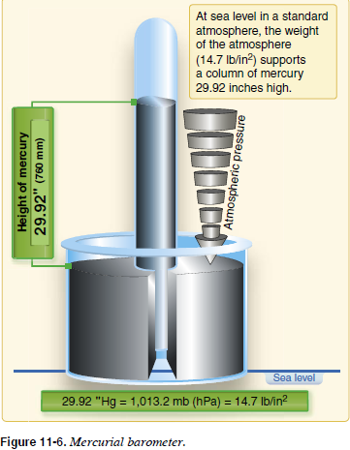

An aneroid barometer is an alternative to a mercurial barometer; it is easier to read and transport. [Figure 11-7] The aneroid barometer contains a closed vessel, called an aneroid cell that contracts or expands with changes in pressure. The aneroid cell attaches to a pressure indicator with a mechanical linkage to provide pressure readings. The pressure sensing part of an aircraft altimeter is essentially an aneroid barometer. It is important to note that due to the linkage mechanism of an aneroid barometer, it is not as accurate as a mercurial barometer.
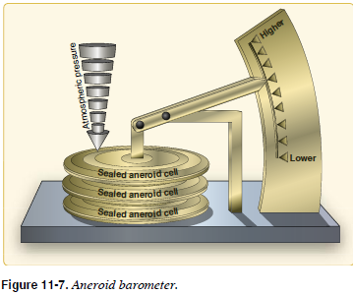

To provide a common reference, the International Standard Atmosphere (ISA) has been established. These standard conditions are the basis for certain flight instruments and most aircraft performance data. Standard sea level pressure is defined as 29.92 "Hg and a standard temperature of 59 °F (15 °C). Atmospheric pressure is also reported in millibars (mb), with 1 "Hg equal to approximately 34 mb. Standard sea level pressure is 1,013.2 mb. Typical mb pressure readings range from 950.0 to 1,040.0 mb. Constant pressure charts and hurricane pressure reports are written using mb.

Since weather stations are located around the globe, all local barometric pressure readings are converted to a sea level pressure to provide a standard for records and reports. To achieve this, each station converts its barometric pressure by adding approximately 1 "Hg for every 1,000 feet of elevation. For example, a station at 5,000 feet above sea level, with a reading of 24.92 "Hg, reports a sea level pressure reading of 29.92 "Hg. [Figure 11-8] Using common sea level pressure readings helps ensure aircraft altimeters are set correctly, based on the current pressure readings.

By tracking barometric pressure trends across a large area, weather forecasters can more accurately predict movement of pressure systems and the associated weather. For example, tracking a pattern of rising pressure at a single weather station generally indicates the approach of fair weather. Conversely, decreasing or rapidly falling pressure usually indicates approaching bad weather and, possibly, severe storms.

